Understanding Product Popularity: Insights from highest profitability, Sales, and Ship Modes
Dela Cruz, John Kevin T.
Jose Rizal University

Abstract— Understanding the factors that drive product popularity is critical for optimizing business strategies and improve customer satisfaction. This study investigates what is the relationship of profitability, sales, and ship modes on particular product popularity. The primary dataset, Superstore Retail Dataset, includes attributes contributing to product success, such as Order Date, Ship Mode, Region, Category, Sales, Discount, Quantity, and Profitability.
Additional analyses involve the use of sorting and filtering techniques to organize and analyze data, identifying products with the highest profitability. Conditional formatting is applied to visually highlight trends and anomalies in profitability, sales performance, and ship modes. Furthermore, insights from Q1, Q2, and Q3 datasets reveal the key factors contributing to regional and product profitability, along with the relationship between Ship Mode and Order Date in shaping customer satisfaction

Keywords— Superstore Retail, Descriptive Statistics, sorting and filtering, conditional formatting, Segment, Region, Category, Sales, Quantity, Discount, and Profit.

Introduction (Heading 1)
The Superstore Retail Dataset is a widely used synthetic dataset designed for educational purposes, focusing on data analysis, visualization, and machine learning in retail analytics. It represents sales data from a fictional retail store operating across various U.S. regions, with comprehensive information about orders, customers, products, and transactions spanning 2014–2018. The dataset includes key attributes such as Order Date, Ship Date, Ship Mode, Customer Segment, Region, Sales, Discount, Quantity, and Profit.
These variables support analyses ranging from profitability and sales trends to customer segmentation and shipping logistics. Techniques like sorting, filtering, and conditional formatting are often employed to uncover trends, patterns, and anomalies, enabling the exploration of critical business questions such as identifying profitable products or evaluating the impact of discounts on profit margins. The dataset is valuable for academic and industry research in areas like marketing, supply chain management, and customer satisfaction. It fosters hands-on learning by allowing users to practice data preprocessing, statistical analysis, and modeling without relying on sensitive real-world data. Freely accessible on platforms like Kaggle and GitHub, it serves as a robust tool for building insights and solving retail business problems.

Domain Description
The Superstore retail dataset is a popular resource for data analysis, visualization, and machine learning projects, especially in the context of retail analytics. It contains sales data from a fictional retail store that operates across multiple regions. The dataset provides comprehensive information about orders, sales, customers, and products, making it ideal for building data-driven insights and models.
This dataset captures the essence of retail operations, offering insights into various dimensions such as product categories, customer demographics, and shipping strategies. Its organized structure enables a deep dive into regional sales trends, profitability metrics, and shipping efficiency. By leveraging this dataset, analysts can uncover actionable insights and effectively forecast future business outcomes.

Problem Statement
This exploratory data analytics question aims to gain insights on regional sales trends, product categories top sales, and ship modes. As well as, identify strategies.
Q1. Which regions demonstrate the strongest profitability, and what roles do Sales figures and chosen Ship Modes play in shaping these outcomes?

Q2. What is the most profitable product categories, along with which factors influence the performance of a product category?

Q3. What is the relationship between Ship Mode and Order Date on customer satisfaction.

Data Collection

Dataset Description
The Superstore Retail Dataset is widely recognized as a valuable resource for data analysis, visualization, and machine learning projects, particularly in retail analytics. It contains synthetic sales data from a fictional retail store operating across multiple regions, offering rich insights into orders, sales, customers, and products. Originally compiled by Yashi Sharma (@yashi-04), this dataset was created three weeks ago with an educational focus. Versions commonly available, such as on Kaggle, simulate data from 2014 to 2018.Designed for academic and professional training, the dataset serves as a hands-on tool for developing skills in data analysis, statistics, and business analytics while maintaining data privacy. It encourages exploration of key research questions, including identifying profitable products, analyzing sales trends by region, and assessing the impact of discounts on profit margins. Additionally, it enables practical problem-solving, such as optimizing inventory, improving shipping logistics, enhance data driven decision making and enhancing customer satisfaction.

Data Exploration
Superstore Retail Dataset contain 21 attributes, 14 remained due to their relevance on Exploratory Data Analysis:

Order ID: When a customer or buyer puts an order, they are given an Order ID. Types of order IDs differ throughout companies; every format is unique to the company and streamlines the order fulfillment procedure. Generally, The characters, digits, and letters that make up the Order ID number format are unique to the business.

Sample Data: CA-2016-152156, US-2015-108966, CA-2014-115812, US-2017-156909

Order Date: It is the day a consumer completes a transaction and purchases anything from you. Given that some businesses have certain delivery deadlines or don't pick and pack items over the weekend, this will often be different from the date of shipment.

Sample Data: 2016-11-08, 2015-10-11, 2014-06-09, 2017-04-15

Ship Mode: is a method of product shipping. A shipping mode is, more precisely, the combination of a shipping carrier and the shipping service such carrier provides. For instance, ABC Shipping Company offers Express or Overnight shipping options

Sample Data: Second Class, Standard Class, Same Day, First Class

Segment: is the process of grouping clients into several categories according to traits including behavior, preferences, and demographics. Gaining further insight into the requirements and inclinations of many client segments is the aim of this endeavor.

Sample Data: Consumer, Home Office, Corporate

Country: refers to the specific nation where an order is placed. often indicating the location of the customer or service provider. This categorization makes it easier to determining possible import regulations and transportation arrangements. It also facilitates the transaction. simple process for both buyers and sellers.

Sample Data: United States

City: The address of the client or the place where the order is being shipped is indicated by the word "city." Considering that various locations may have distinct logistical needs, this When predicting transportation costs and delivery schedules, information is essential. Finding the precise city ensures that there won't be any issues or delays in the order reaching its intended recipient

Sample Data: Henderson, Lafayette, Fairfield. Grand Rapids

State: the purpose of shipping and delivery logistics, the state indicates the exact area of a country where the customer resides. Various states may have different tax laws, shipping alternatives, and regulations, which may have an impact on the total cost and delivery time of the order. Businesses can more effectively adapt their services to local needs and compliance requirements by having a thorough understanding of the state.

Sample Data: Kentucky, Florida, California, Washington

Region: The home region of the client, whether it be East, West, Central, or South, is shown by the area. Geographical service accessibility, customer preferences, and freight logistics can all be This classification's effects

Sample Data: East, West, Central, or South

Category: A product is classified into a category, such as Technology, Office Supplies, or Furniture, according to its features and intended application. This company enhances the buying experience for customers by making it simple for them to explore and find products that suit their needs.

Sample Data: Technology, Office Supplies, Furniture

Product Name: The product name is used to distinguish and identify the specific item. being offered for sale with other products in the same or similar categories. Important attributes or advantages can be An appealing and eye-catching product name can be used to convey and attract customers. It is vital to branding and marketing since it shapes consumer opinions and purchasing.

Sample Data: Bush Somerset Collection, Bookcase, Xerox 1987, American Pencil, White Envelopes with Clear Poly Window

Sales: this are defined as the total amount of money received from each order and represent the monetary worth of the goods sold. This measure is essential for evaluating the profitability and performance of businesses, which helps to guide financial strategy. Inventory and marketing decisions can be made with the help of sales data analysis, which can identify trends, peak times, and client preferences.

Sample Data: $261.96, $731.94, $952.58, $15.55

Quantity: it describes how many units of a product are included in a customer's order. Businesses can use this information to track stock levels and forecast replenishment needs, which is essential for inventory management. Planning for production and sales might also benefit from knowing the quantity ordered.

Sample Data: 2, 3, 5 ,1

Discount: percentage of a product's initial cost that is offered in order to purchases and make customers more appealing. By making this financial adjustment, sales can rise. volume by making the products more appealing to customers. Discounts can also be carefully applied to clear inventory or throughout sales, which will influence customer behavior and boost involvement.

Sample Data: 0.3, 0.8, 0.2, 0.7

Profit: is the amount of money made from the sale of a product after all related costs, such as manufacturing and operating expenditures, have been deducted. This measure is essential for evaluating a company's general well-being and long-term viability. Understanding profit margins can help organizations make educated pricing and investment decisions.

Sample Data: $41.9136, $11.7208, $-3.0396

Data Preprocessing
- Data Cleaning
It ensures that the data is accurate, consistent, and ready for meaningful insights.

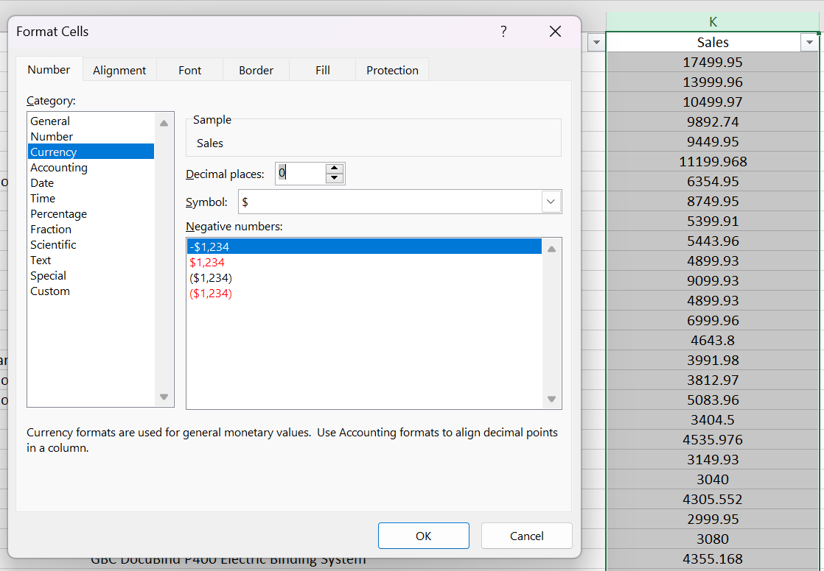

First, applying proper format for Sales and Profit which is Currency

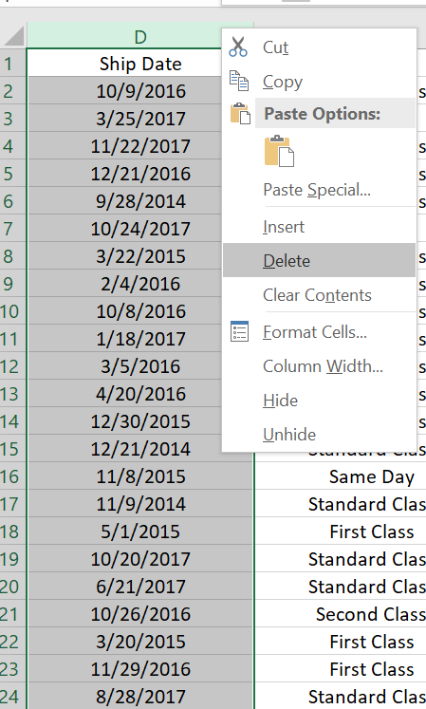
Next step that I take is removing irrelevant attributes based on my exploratory data analysis that I made.

- Identifying Outliers
For example, in Q2 I found outliers in the column of Quantity, I decided to remove outliers and it shows that it has a huge impact in data analysis and it might lead to inaccurate conclusion.
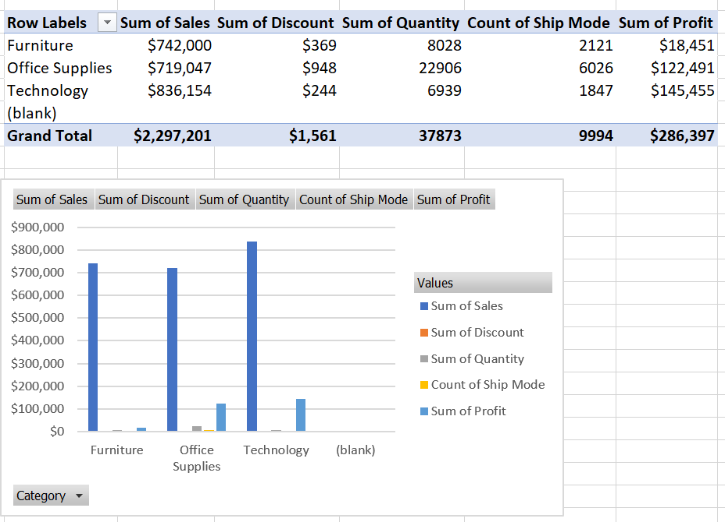

Original Data Analysis of most profitable product categories, and factors that influence the performance of product.

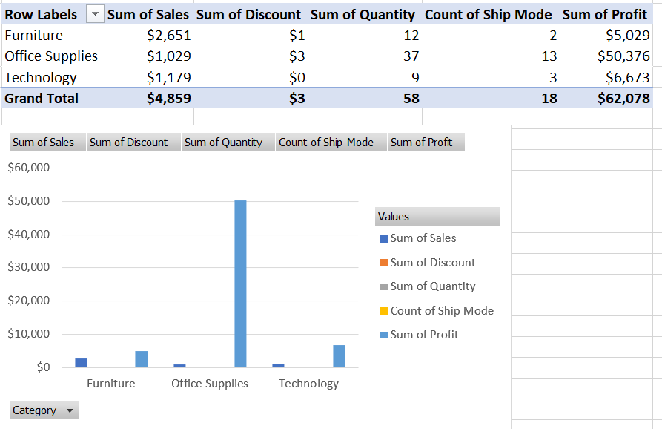

After Identifying Outliers, I apply sorting and filtering to help me analyze which region or product category has highest profitability and sales

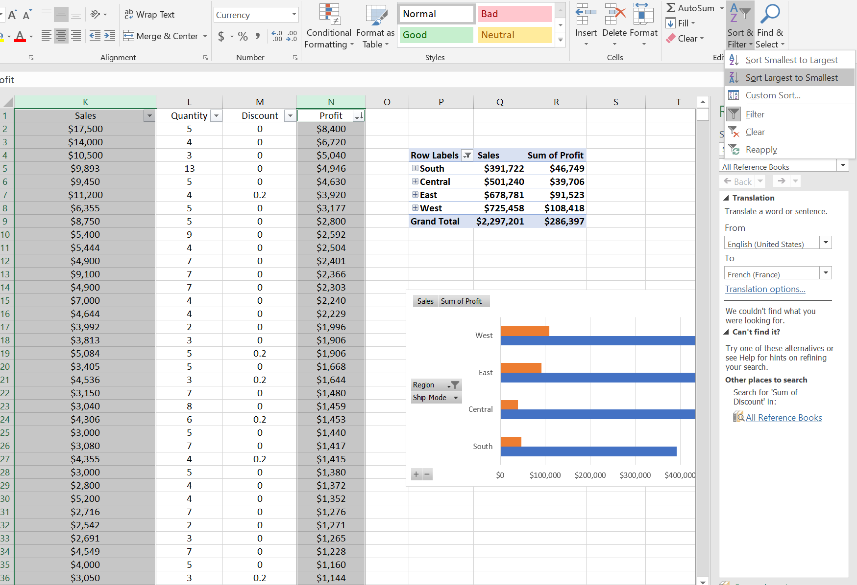
Lastly, I implemented Conditional Formatting in order to visualize data in a meaningful way. As you can see in the image below, I apply it in Sales Column (Above Average and Below Average). The reason for that, is to identify which region has the highest profitability which is West, it shows in my pivot table and bar chart.

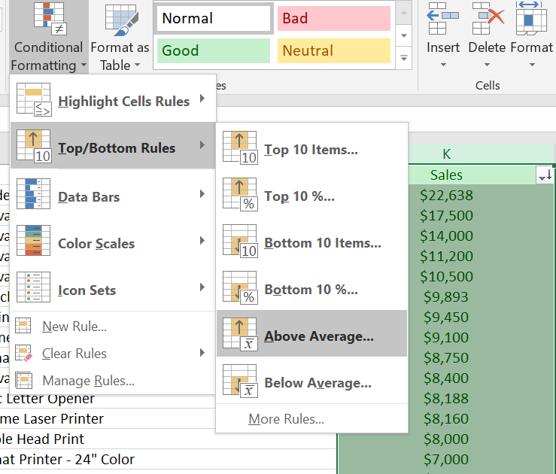
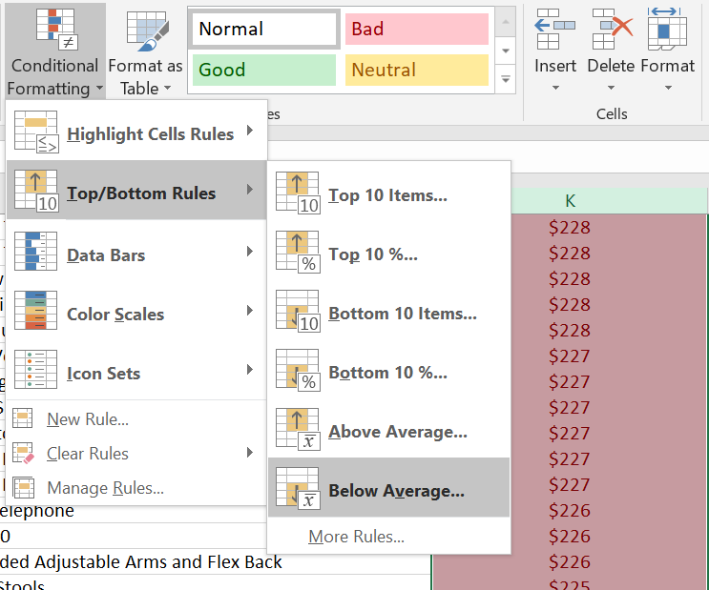

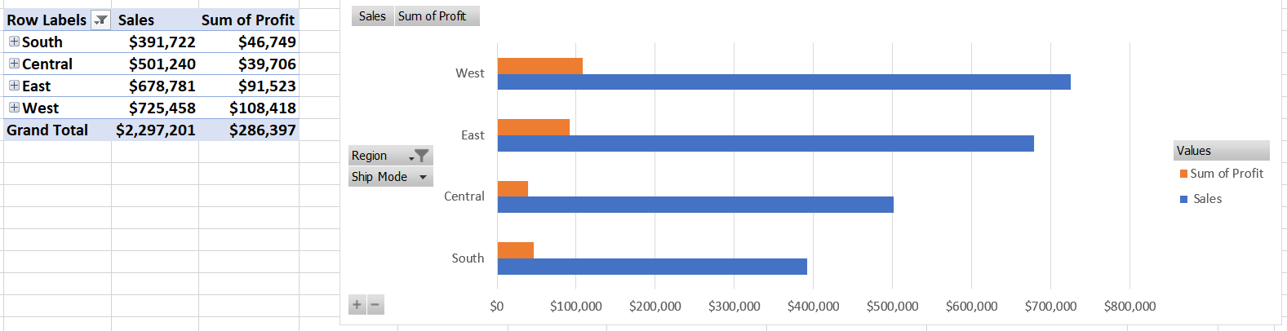

EXPERIMENTAL DESIGN
Experimental Design process is critical for validating and supporting in your objectives. In this dataset, its used to analyzed through a tailored analytical method, using statistical and visual tools in Microsoft Excel to ensure strong research results and can be apply to enhance decision making and creating business strategies.

Q1. Region that has a highes profitability
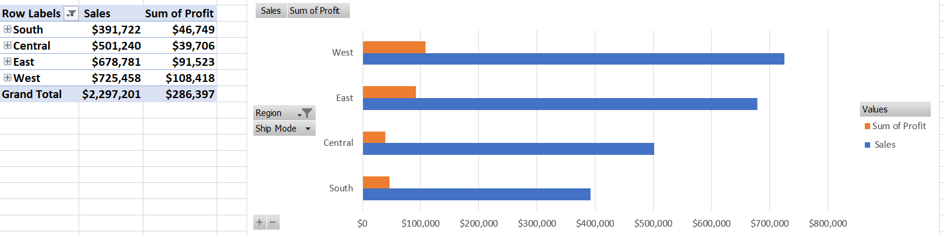
Q2. Most profitable product categories
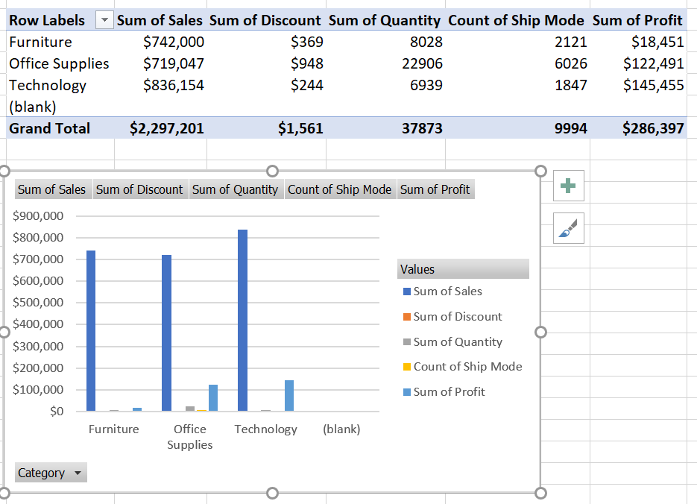
Q3. The relationship between Ship Mode and Order Date
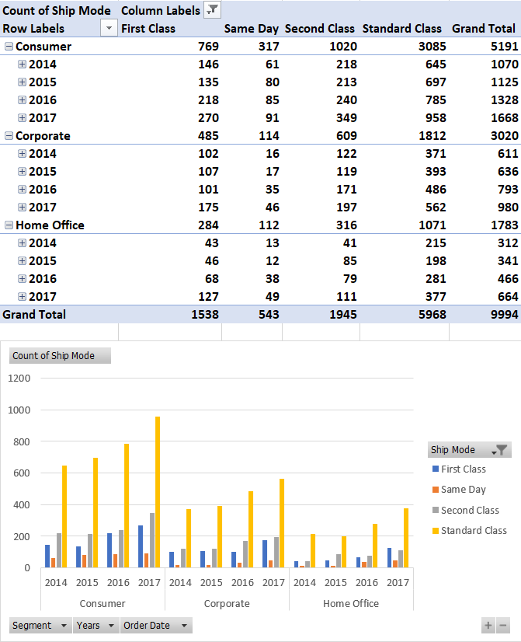

use “Ref. [3]” or “reference [3]” except at the beginning of a sentence: “Reference [3] was the first ...”
Number footnotes separately in superscripts. Place the actual footnote at the bottom of the column in which it was cited. Do not put footnotes in the abstract or reference list. Use letters for table footnotes.
Unless there are six authors or more give all authors’ names; do not use “et al.”. Papers that have not been published, even if they have been submitted for publication, should be cited as “unpublished” [4]. Papers that have been accepted for publication should be cited as “in press” [5]. Capitalize only the first word in a paper title, except for proper nouns and element symbols.
For papers published in translation journals, please give the English citation first, followed by the original foreign-language citation [6].

- G. Eason, B. Noble, and I. N. Sneddon, “On certain integrals of Lipschitz-Hankel type involving products of Bessel functions,” Phil. Trans. Roy. Soc. London, vol. A247, pp. 529–551, April 1955. (references)
- J. Clerk Maxwell, A Treatise on Electricity and Magnetism, 3rd ed., vol. 2. Oxford: Clarendon, 1892, pp.68–73.
- I. S. Jacobs and C. P. Bean, “Fine particles, thin films and exchange anisotropy,” in Magnetism, vol. III, G. T. Rado and H. Suhl, Eds. New York: Academic, 1963, pp. 271–350.
- K. Elissa, “Title of paper if known,” unpublished.
- R. Nicole, “Title of paper with only first word capitalized,” J. Name Stand. Abbrev., in press.
- Y. Yorozu, M. Hirano, K. Oka, and Y. Tagawa, “Electron spectroscopy studies on magneto-optical media and plastic substrate interface,” IEEE Transl. J. Magn. Japan, vol. 2, pp. 740–741, August 1987 [Digests 9th Annual Conf. Magnetics Japan, p. 301, 1982].
- M. Young, The Technical Writer’s Handbook. Mill Valley, CA: University Science, 1989.

IEEE conference templates contain guidance text for composing and formatting conference papers. Please ensure that all template text is removed from your conference paper prior to submission to the conference. Failure to remove template text from your paper may result in your paper not being published.

